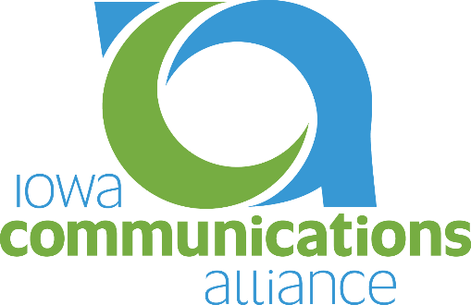

Iowa Communications Alliance Job Posting Intake Form

Please provide The Iowa Communications Alliance any pertinent information related to your job posting. If the expiration date is not included, the job will be posted for 30 days after the received date. Email Melissa Primus at Melissa@IACommunicationsAll.com completed forms to have them posted on the website.

COMPANY NAME:

JOB TITLE:

SALARY:

HOURS:

POST DATE:

EXPIRATION DATE:

JOB DESCRIPTION:

COMPANY CONTACT INFORMATION:

