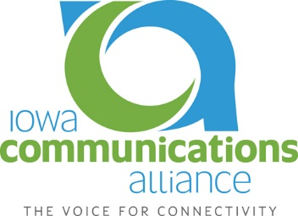

Talking Points for ICA Members to use in
Meetings with County Emergency Management Coordinators

- Ask the county what they expect/assume of their service provider for telephone to:
  - E911
  - Public safety
  - Subscribers
- Provide detailed of telco inventory -- equipment locations and requirements including power consumption and fuel needs. Identify where equipment resides and what we need in order to keep them operational or return to service.
- Identify and explain the communications services affected by the equipment and locations above. What areas will not receive what services after how long.
- Detail the different providers and service areas for this county. Telco GMs can provide contact information and organize a meeting of the ITC's within this county and/or a regional type meeting with the surrounding counties coordinators and service providers.
- Obtain list of county assets
  - get an understanding of what kind of generator and generator-related fuel they have access to and what they expect to use them for.
  - Ask what kind of priority the telco might receive for generator-related fuel and service repair
- Agree on a list of prioritized locations – Emergency Management, Sheriff PSAP, Hospitals, Care Centers, Clinics, Cell Towers, City (sewer & water)etc.
- Discuss any and all gaps between expectation and reality – both between telco and the county.
- Security – If our office is the only or one of a few locations in town with generator, fuel, heat, communication, etc. – how do we keep our facility safe?
- Different scenarios depending on the time of year? What changes from June verses January?
- Identify any known and available expected video or communications mechanisms to be used for news and alerts)

